ID Card: Front of card ID Card: Back of card
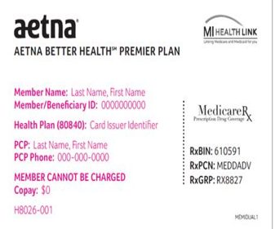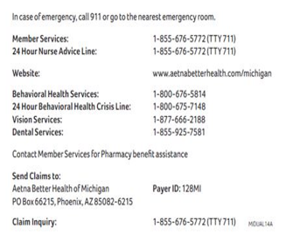
- Aetna Better Health of Michigan home page website: https://www.aetnabetterhealth.com/michigan
- Aetna Better Health of Michigan Provider Resources: https://www.aetnabetterhealth.com/michigan/providers/
  - Join Our Network, Prior Authorization, Provider Manual, Case/Disease Management, Clinical Practice Guidelines, Provider Portal, Forms, News & Notices, Newsletters, Claims, Training, Resources
- Availity home page web Portal: www.availity.com
  - Log in to Essentials or call 1-800-282-4528
- Availity Portal Tools & Resources:
  - Eligibility, Claims, Prior Authorizations, PAR Provider Disputes, Grievance and Appeals, Panel Roster and more
- How to verify member eligibility, PCP assignment, benefits, co-pays/deductibles:
    - State CHAMPS website: www.michigan.gov
    - ABH Provider Portal: https://www.aetnabetterhealth.com/michigan/find-provider
    - Availity Secure Portal: www.availity.com
- How to File a Claim:
  - Electronic Claims Submission (EDI)
    - Electronic Claims Submission: Change Health (Emdeon) is the EDI vendor we use Medicare and Medicaid https://www.changehealthcare.com/
    - Payer ID: 128MI
  - Paper Claims:
    - Aetna Better Health OF Michigan PO Box 982963 El Paso, TX 79998-2963
- Claims Timely Filing:
  - New Claim: within 365 days from Date of Service
  - COB Claim: within 365 from the date of the COB remittance advice
  - Claim Resubmission: within 180 days from the date of payment or denial
  - Appeals and reconsiderations: 180 days from the original denial for appeal and reconsiderations
- Prior Authorization online tool: https://www.aetnabetterhealth.com/michigan/providers/prior-authorization
  - Select Prior Authorizations to determine if prior authorization (PA) is required
    - Enter CPT or HCPCS Code (s) up to six can be entered
    - Select Plan
      - ABH of Michigan – MMP Duals (Medicare/Medicaid)
      - Michigan Medicaid-Medicaid/Healthy MI
    - Phone: 1-855-676-5772 Fax: 1-844-241-2495
- Provider Appeal:
  - Phone: 866-316-3784 Fax: 866-889-7517
  - Mail: Aetna Better Health of Michigan Attn: Provider Grievance
    - PO Box 818070 5801 Postal Road Cleveland, OH 44181-0040
  - Email: MIAppealsandGrievances@aetna.com
  - Secure Portal: https://www.aetnabetterhealth.com/michigan/providers/portal
- Claims Inquiry Claims Research (CICR) Department: benefits, eligibility, claim status, appeal status, check tracers, remits, COB, Billing and Coding
  - MI Duals: 1-855-676-5772 Medicaid/Healthy MI: 1-866-316-3784
- Vendors:
  - CVS Health Pharmacy Benefits Manager: 1-800-552-8159
  - DentaQuest Dental Benefits Manager: 1-866-316-3784
  - VSP Vision Benefits Manager: 1-800-877-7195
  - Medical Transportation Management: 1-844-549-8347
  - eviCore Health Radiology Benefits Manager: 1-888-693-3211
- Provider Representatives:
  - Patti Pogodzinski: pogodzinskipatti@aetna.com

